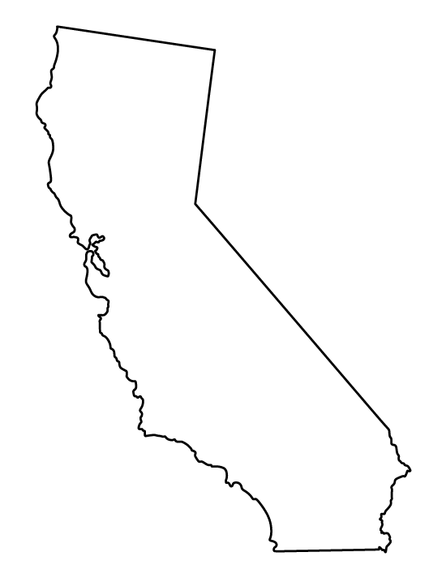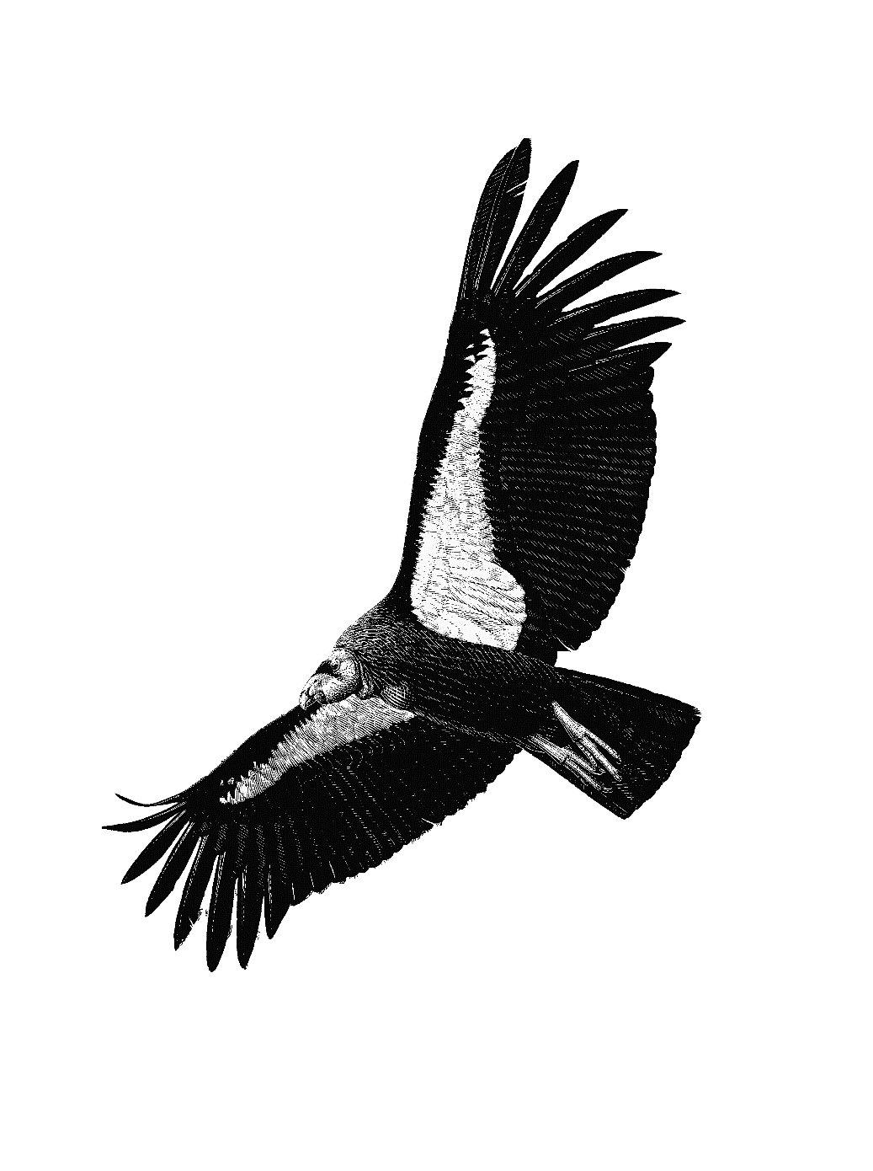

Use words, drawings, arrows, and different colors to create your PRELIMINARY MODEL connecting the California condor within the ***ecosystem***.