California condor GIS Lab Photobook

20
79
247
262
374
457
518
590
599
616
755
771
791
805
818
864
933
943
949
950

Studbook Number: #020 (Male)
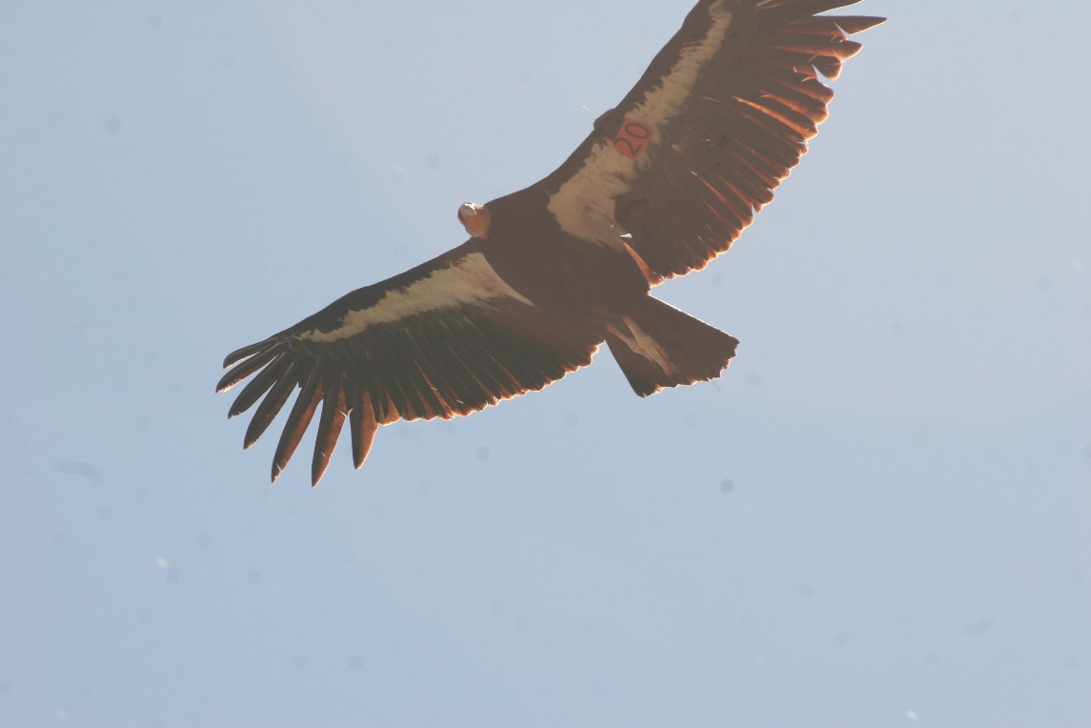
Hatch Date: January 1, 1980
Hatch Location: Southern California Wild Wild Fledge: Yes
Mother (Dam): #010
Father (Sire): #006

Condor #79 (Female)
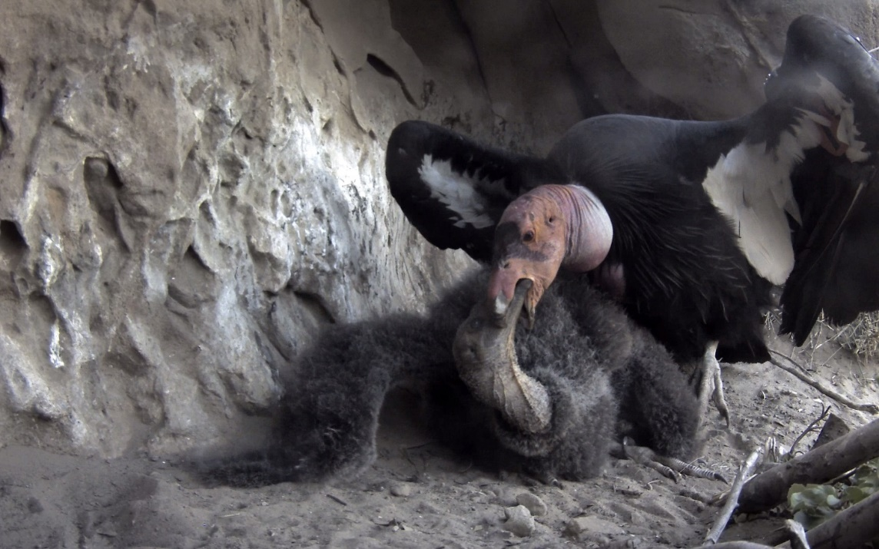
Hatch Date: April 18, 1992
Hatch Location: LA Zoo, California Wild Fledge: No
Mother (Dam): #040
Father (Sire): #021

Condor #247 (Male)
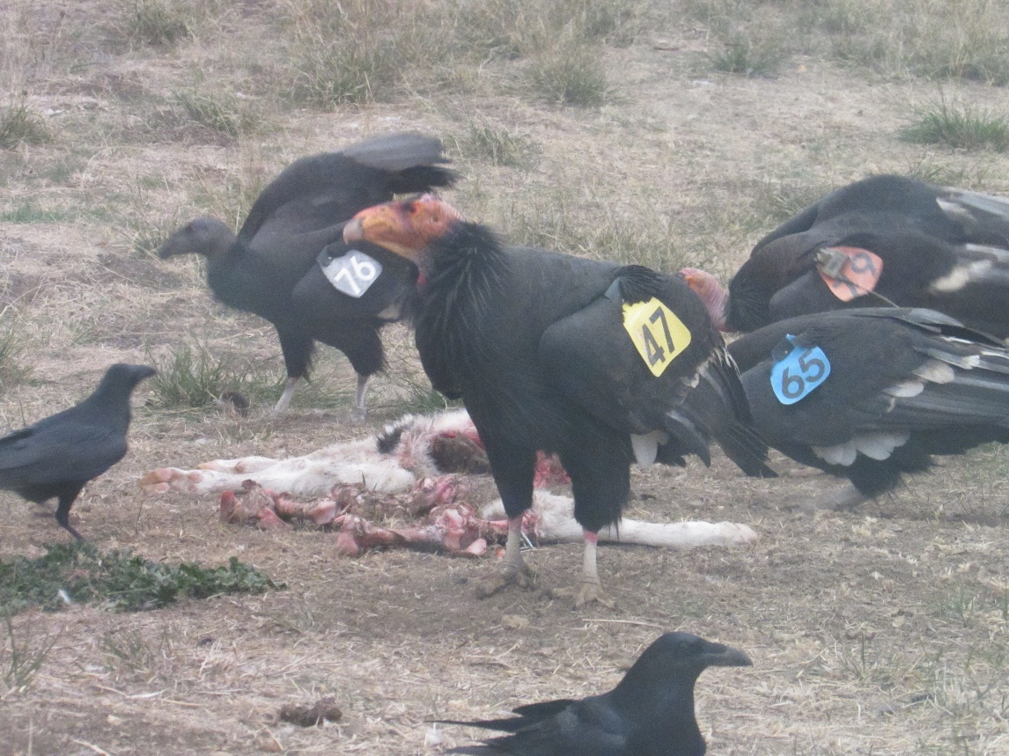
Hatch Date: April 30, 2001
Hatch Location: San Diego Safari Park, California Wild Fledge: No
Mother (Dam): #029
Father (Sire): #020

Condor #262 (Male)
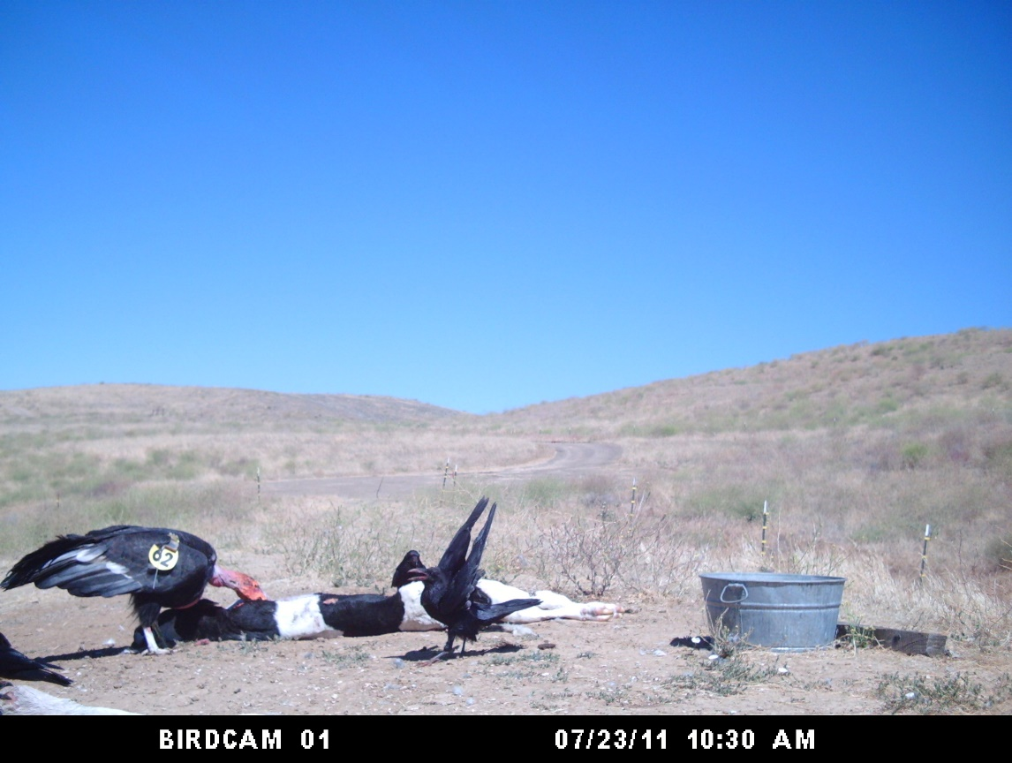
Hatch Date: June 17, 2001
Hatch Location: LA Zoo, California Wild Fledge: No
Mother (Dam): #111
Father (Sire): #100

Condor #374 (Male)
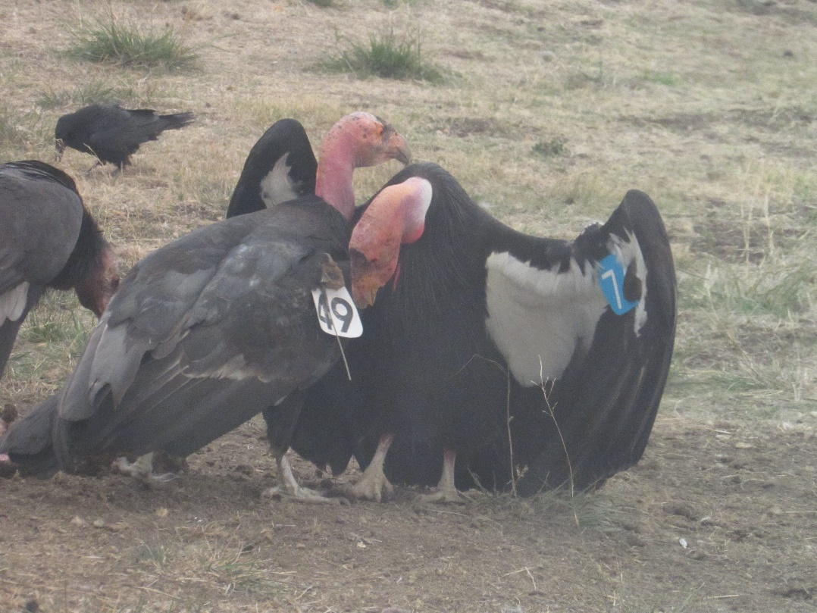
Hatch Date: April 29, 2005
Hatch Location: LA Zoo, California Wild Fledge: No
Mother (Dam): #068
Father (Sire): #033

Condor #457 (Male)
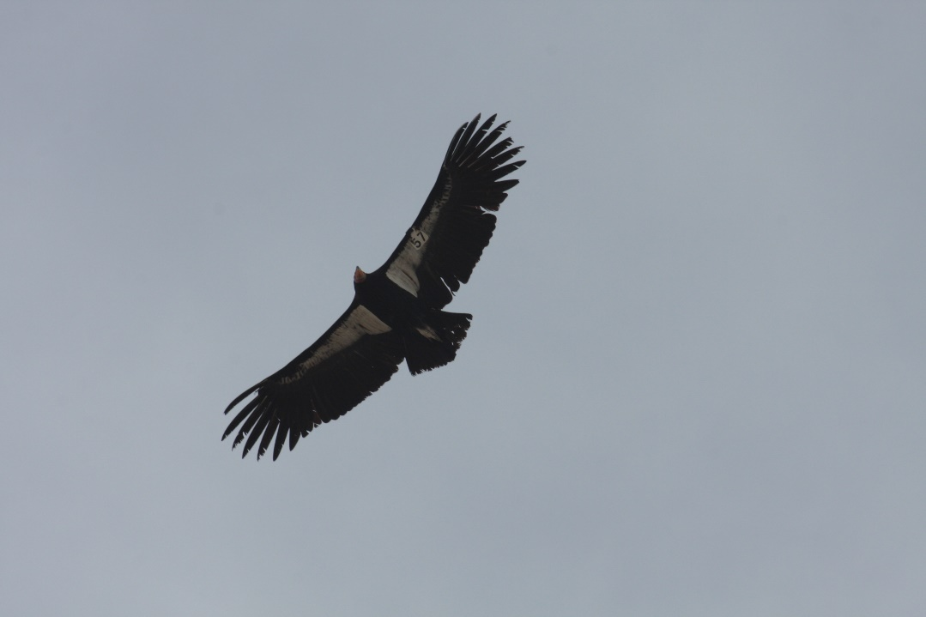
Hatch Date: June 2, 2007
Hatch Location: LA Zoo, California Wild Fledge: No
Mother (Dam): #039
Father (Sire): #042

Condor #518 (Female)
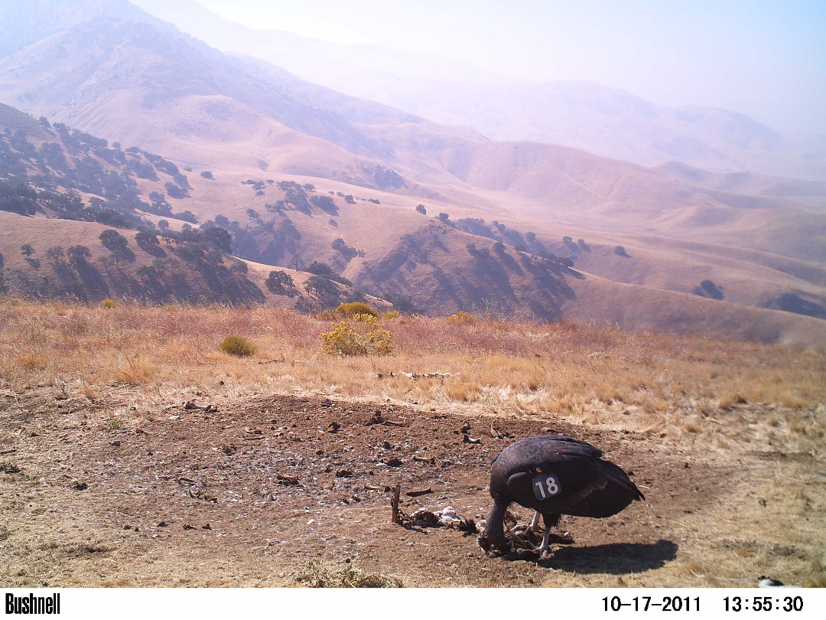
Hatch Date: April 26, 2009
Hatch Location: World Center for Birds of Prey, Idaho Wild Fledge: No
Mother (Dam): #051
Father (Sire): #047

Condor #590 (Male)
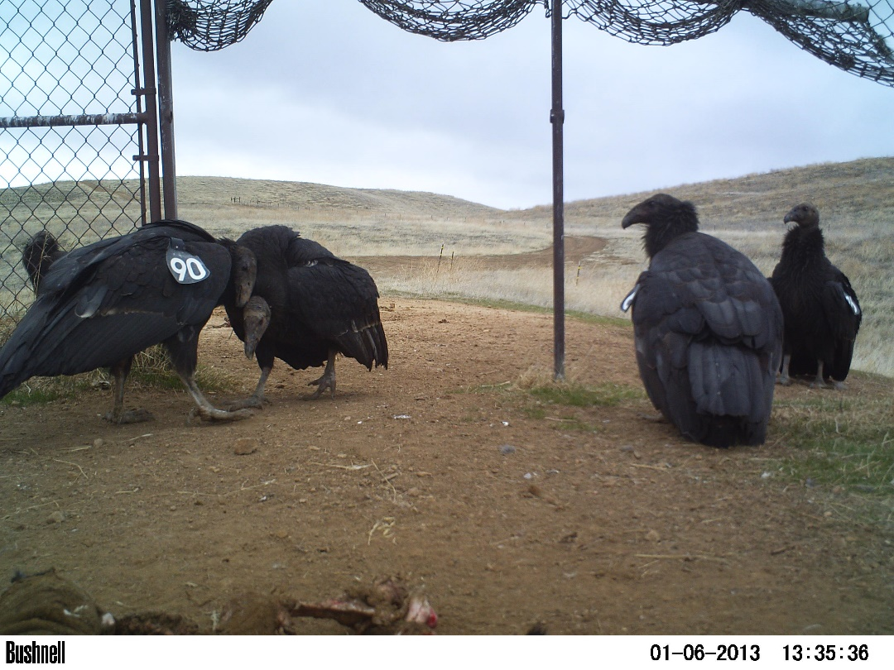
Hatch Date: March 14, 2011
Hatch Location: San Diego Safari Park, California Wild Fledge: No
Mother (Dam): #054
Father (Sire): #028

Condor #599
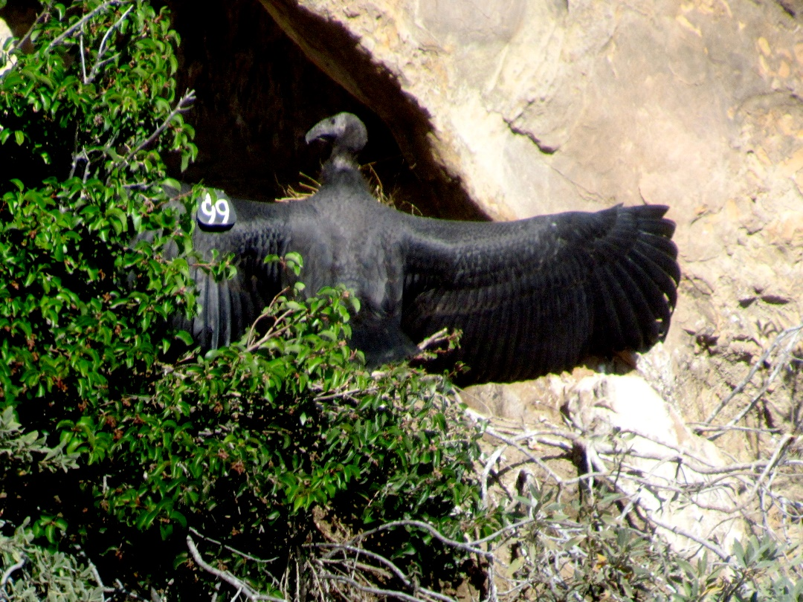
Hatch Date: April 8, 2011
Hatch Location: LA Zoo, California Wild Fledge: Yes
Mother (Dam): #317
Father (Sire): #330
Egg transferred to wild from LA ZOO
Wild Foster Parents: Female #079 and Male #247

Condor #616 (Female)
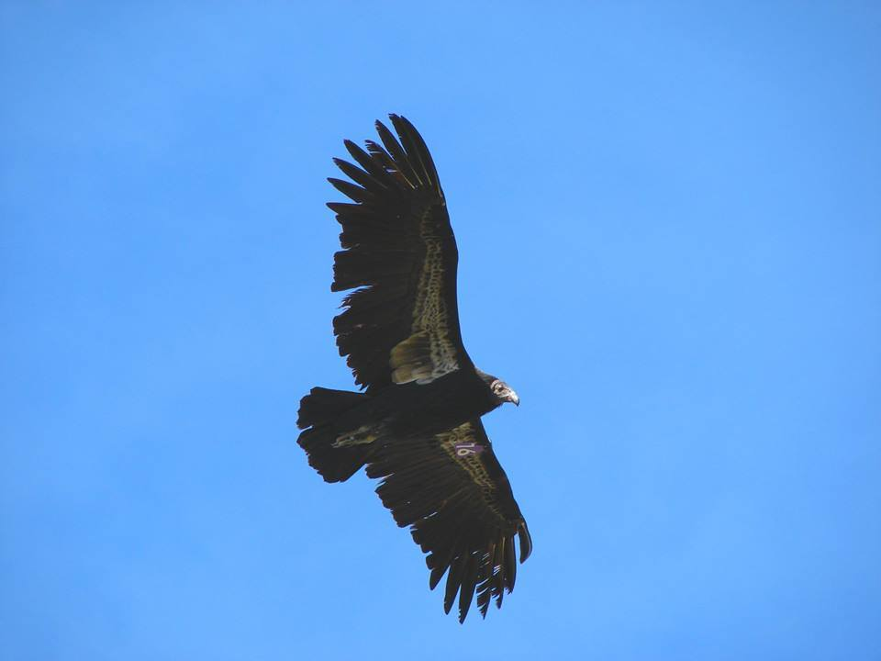
Hatch Date: April 21, 2011
Hatch Location: Southern California Wild Wild Fledge: Yes
Mother (Dam): #161
Father (Sire): #107

Condor #755 (Male)
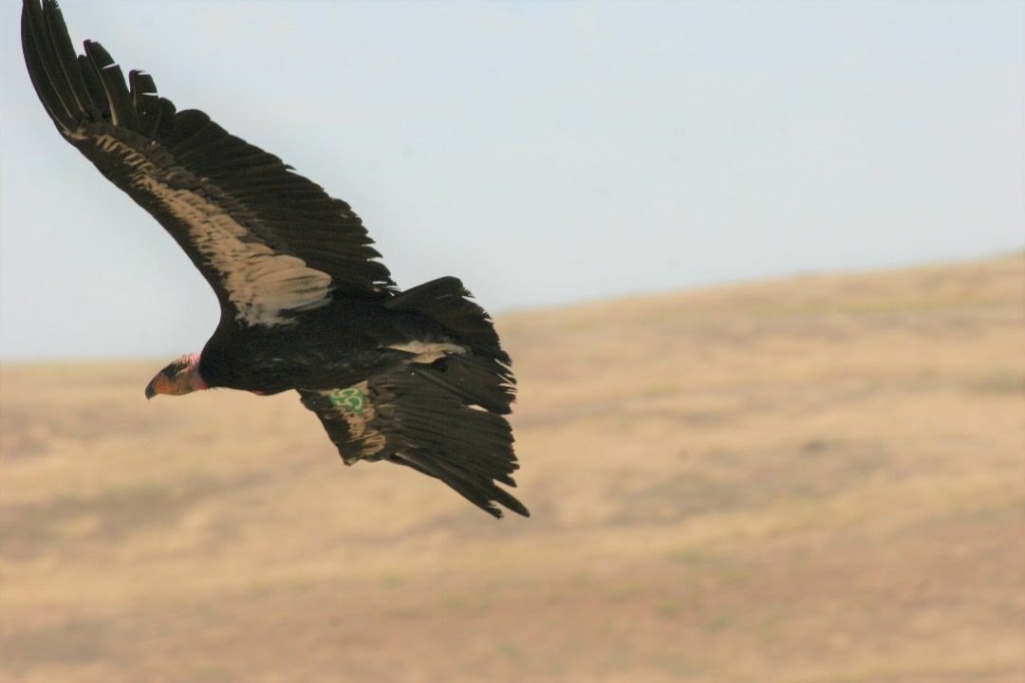
Hatch Date: May 8, 2014
Hatch Location: World Center for Birds of Prey, Idaho Wild Fledge: No
Mother (Dam): #093
Father (Sire): #062

Condor #771 (Female)
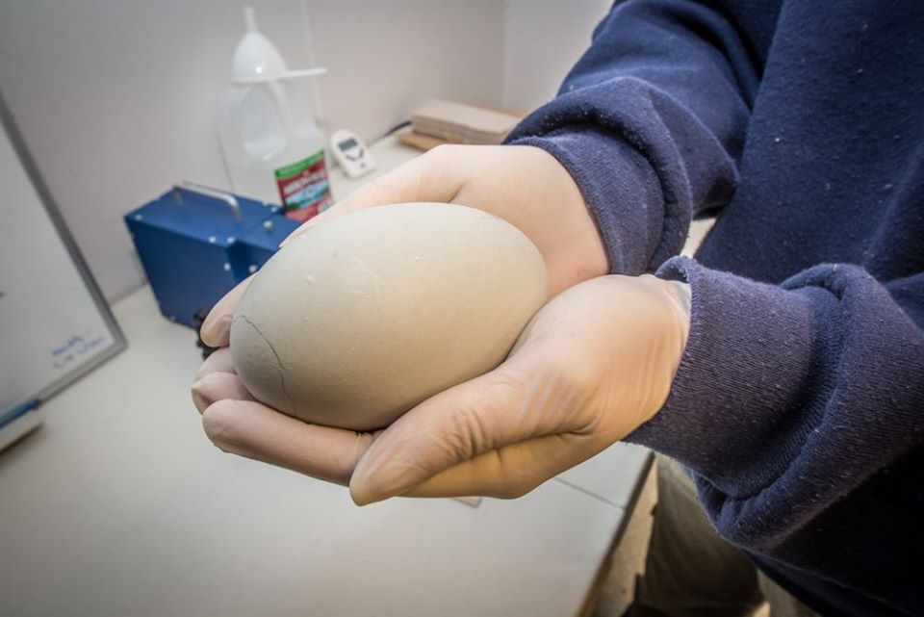
Hatch Date: March 24, 2015
Hatch Location: Portland Zoo, Oregon Wild Fledge: No
Mother (Dam): #108
Father (Sire): #295
Video of captive breeding of #771 at Oregon Zoo

Condor #791 (Female)
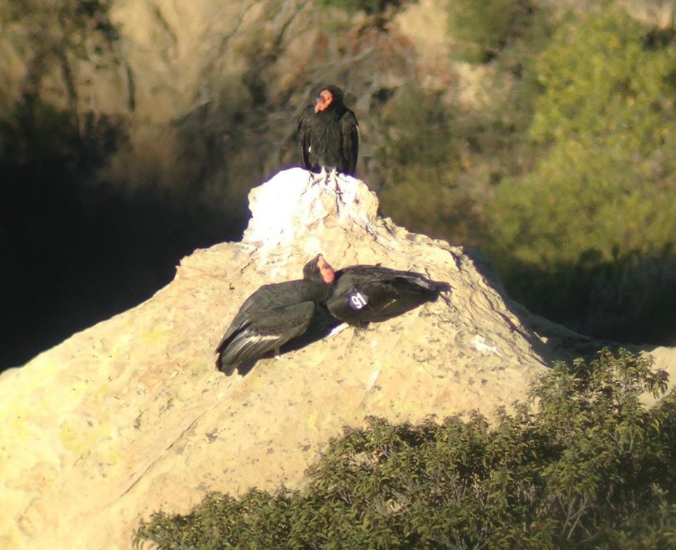
Hatch Date: May 1, 2015
Hatch Location: Southern California Wild Wild Fledge: Yes
Mother (Dam): #068
Father (Sire): #001
Egg was transferred to wild from LA Zoo
Wild Foster Parents: Female #518 and Male #326

Condor #805
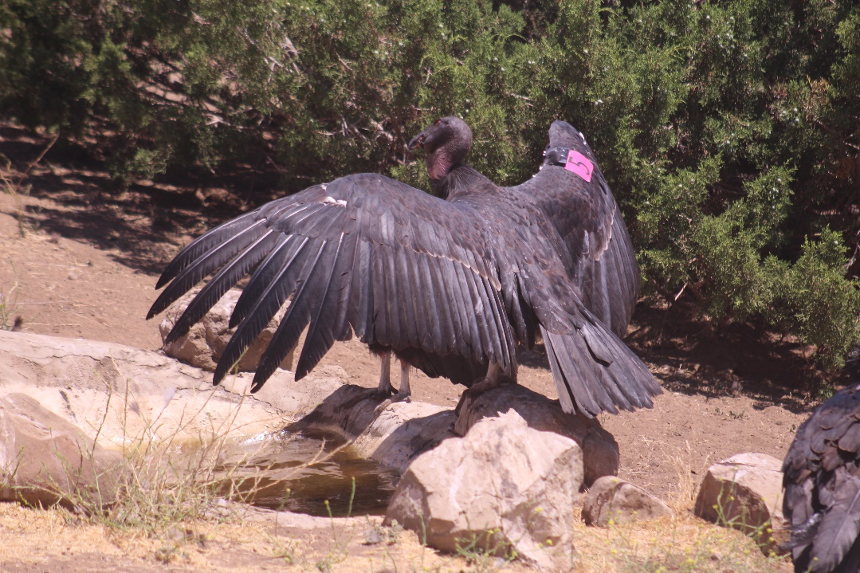
Hatch Date: June 2, 2015
Hatch Location: LA Zoo, California Wild Fledge: No
Mother (Dam): #068
Father (Sire): #001

Condor #818 (Male)
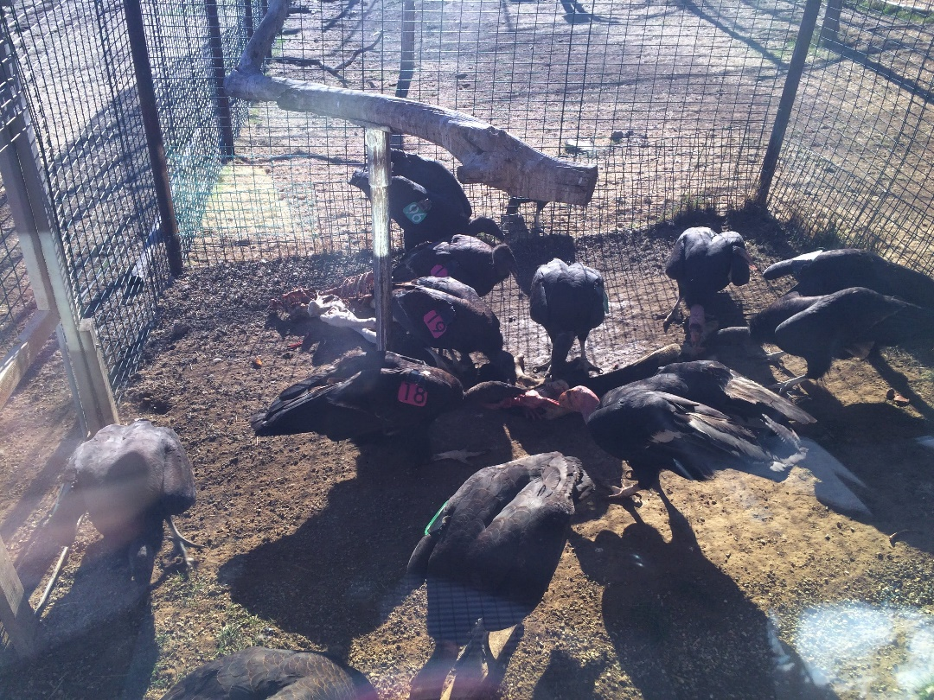
Hatch Date: April 7, 2016
Hatch Location: Portland Zoo, Oregon Wild Fledge: No
Mother (Dam): #492
Father (Sire): #540

Condor #864 (Male)
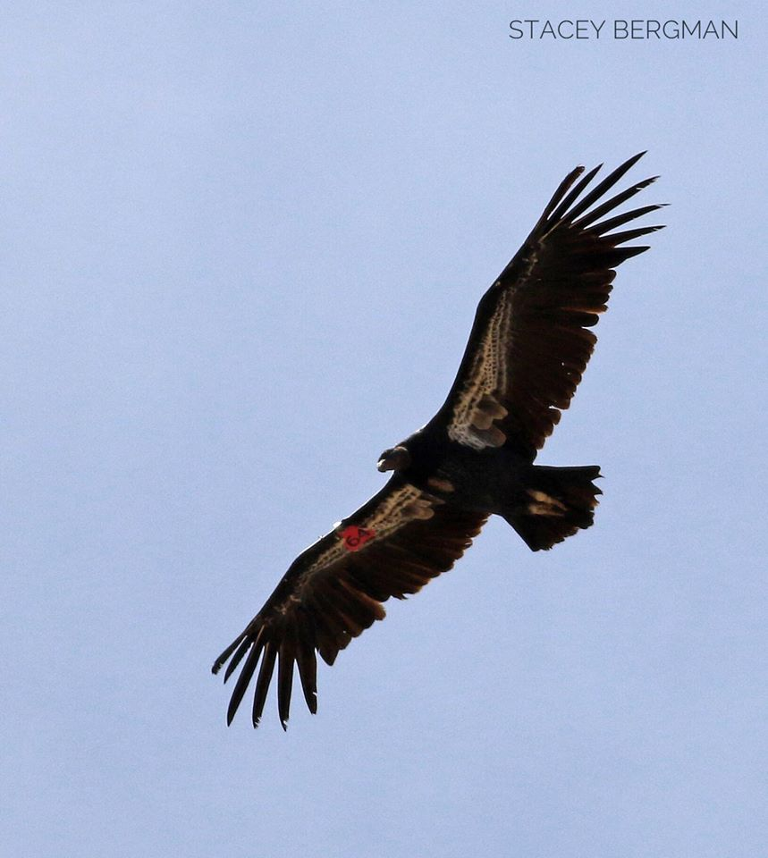
Hatch Date: April 10, 2017
Hatch Location: LA Zoo, California Wild Fledge: No
Mother (Dam): #141
Father (Sire): #005

Condor #933 (Lab results not back)
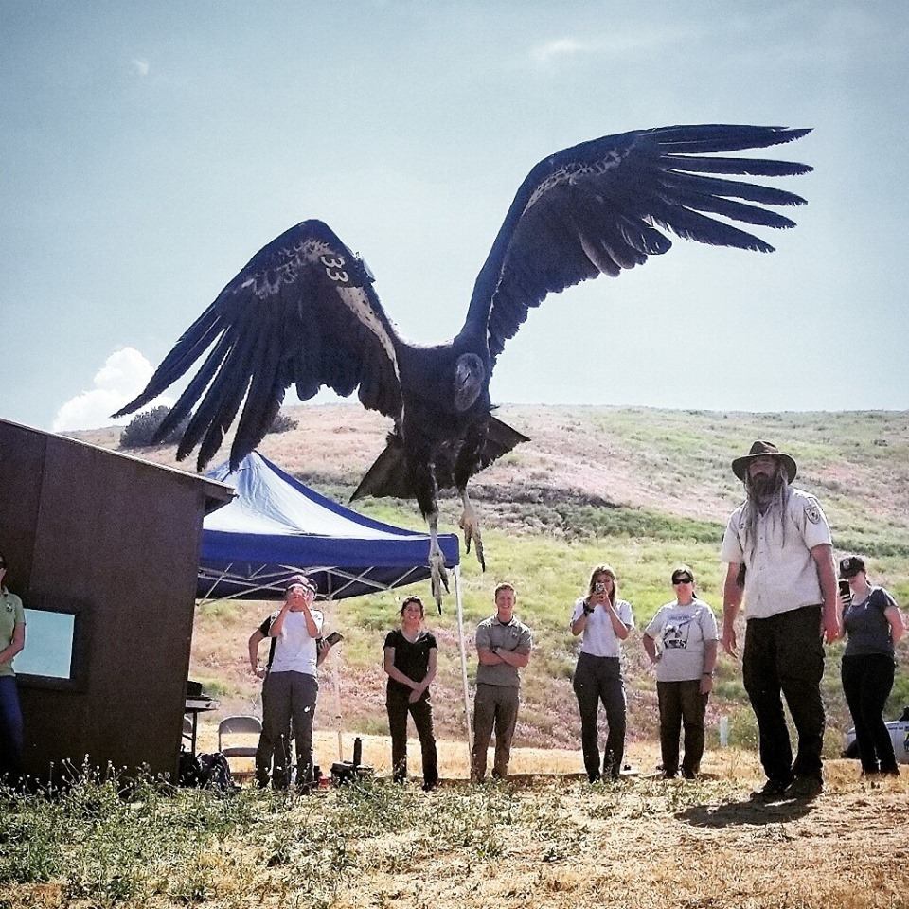
Hatch Date: April 29, 2018
Hatch Location: Southern California Wild Wild Fledge: Yes
Mother (Dam): #654
Father (Sire): #020

Condor #943 (Male)
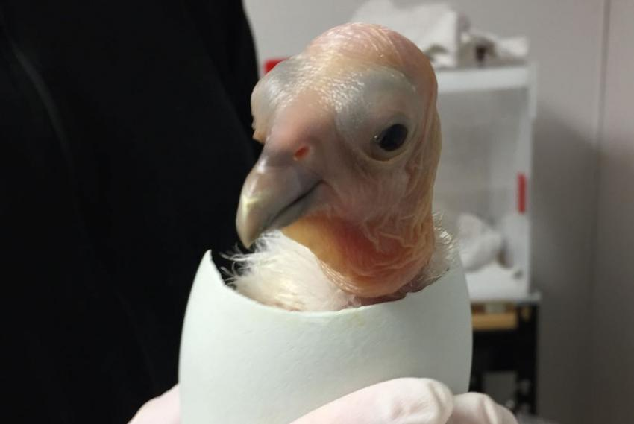
Hatch Date: May 17, 2018
Hatch Location: Portland Zoo, Oregon Wild Fledge: No
Mother (Dam): #037
Father (Sire): #073

Condor #949 (Female)
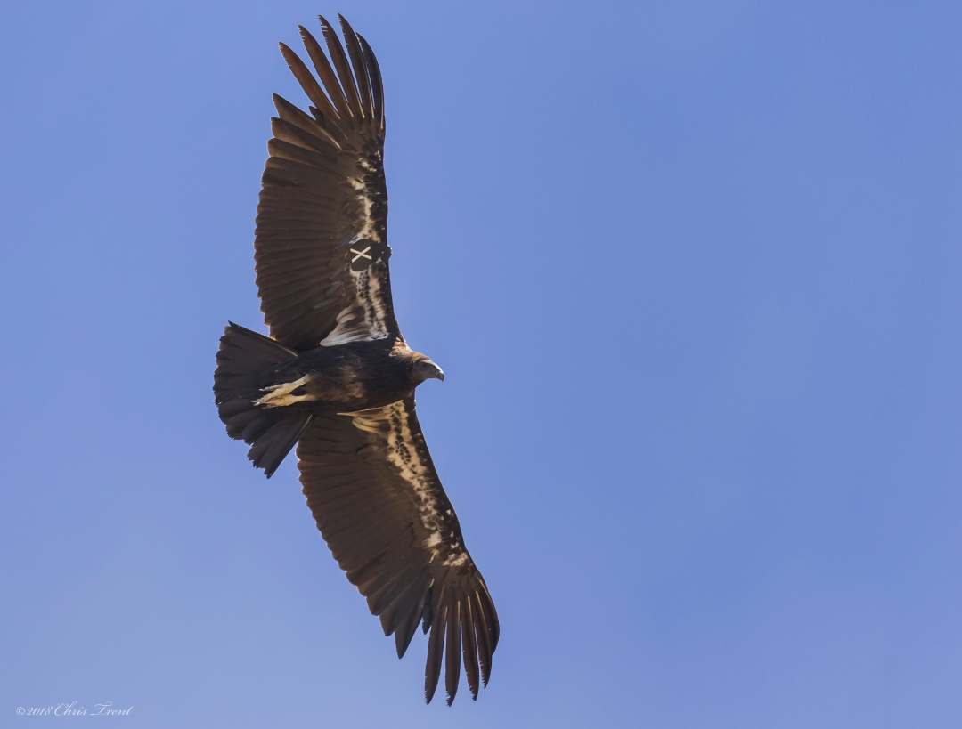
Hatch Date: May 10, 2018
Hatch Location: Southern California Wild Wild Fledge: Yes
Mother (Dam): #576
Father (Sire): #467

Condor #950 (Male)
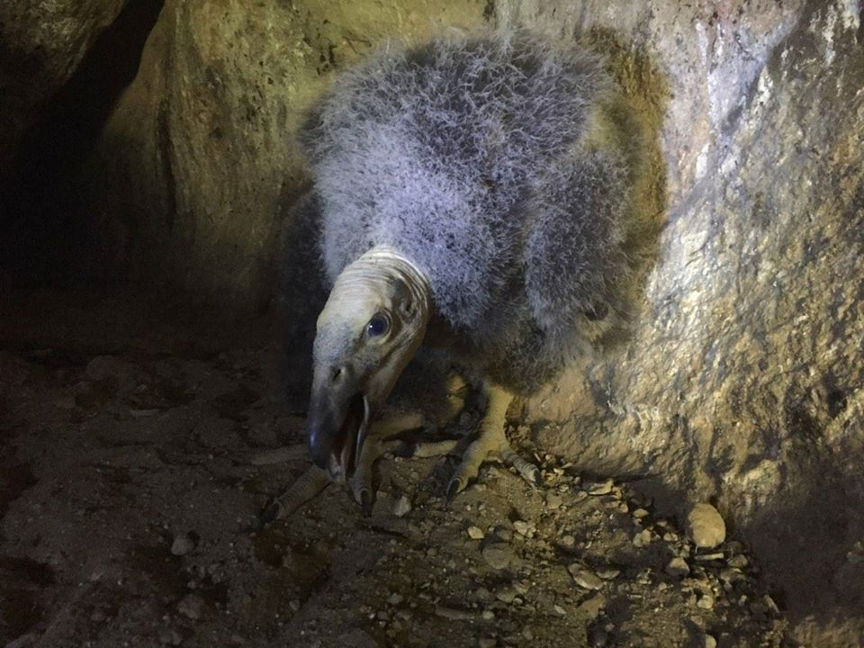
Hatch Date: April 16, 2018
Hatch Location: Southern California Wild Wild Fledge: Yes
Mother (Dam): #161
Father (Sire): #509

