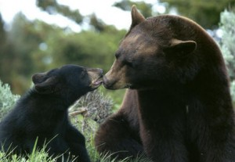
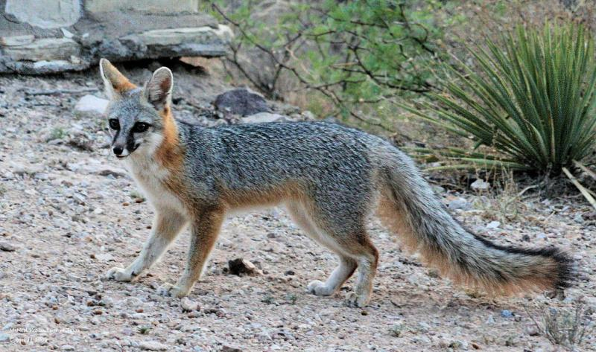

AMERICAN BLACK BEAR (Ursus americanus)
Omnivore – Secondary Consumer
Predators | Prey
Humans | Jack Rabbit
 | Deer
 | Berries
 | Grasses
 | Carrion
 | Coyote and Fox
 | Condors

GREY FOX (Urocyon cinereoargenteus)
Omnivore – Secondary Consumer
Predators | Prey
Mountain Lion | Jack Rabbit, and rodents
Coyote | Deer
 | Berries, and grasses
 | Birds, and eggs
 | Carrion
 | Lizards
 | Condor chicks

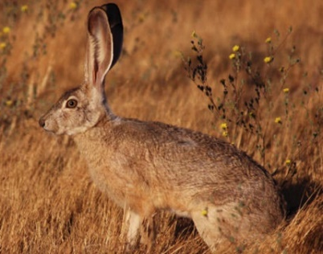
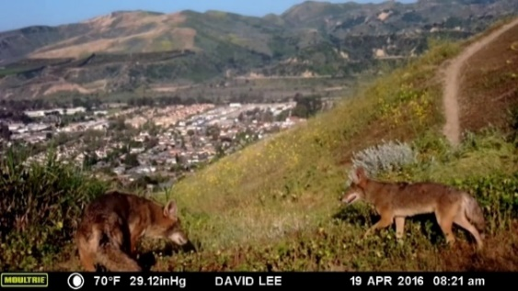

Jack Rabbit (Lepus californicus)
Herbivore – Primary Consumer
Predators | Prey
Humans | Grasses
Coyote
Raptors
Mountain Lion
Bobcat
Black Bear
Grey Fox

Coyote (Canine latrans)
Omnivore – Secondary Consumer
Predators | Prey
Mountain Lion | Jack Rabbit, and rodents
Black Bear | Deer
 | Berries, and grasses
 | Birds, and eggs
 | Carrion
 | Lizards
 | Condors
 | Pets

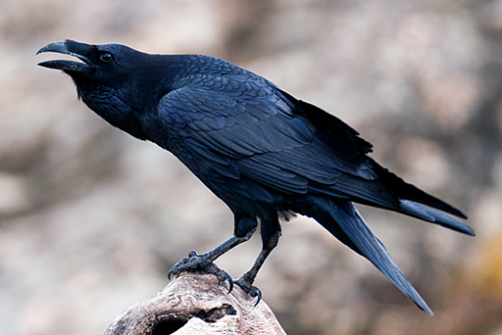
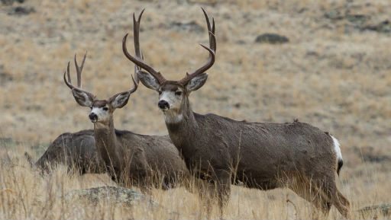

Raven (Corvid corax)
Omnivore – Secondary Consumer
Predators | Prey
Humans | Seeds, fruits, veggies
Coyote | Insects
Raptors | Lizards
Mountain Lion | Carrion
Bobcat
Black Bear
Grey Fox

Mule Deer (Odocoileus hemionus)
Omnivore – Secondary Consumer
Predators | Prey
Mountain Lion | Grasses
Black Bear | Berries
Coyote
Humans
Bobcat
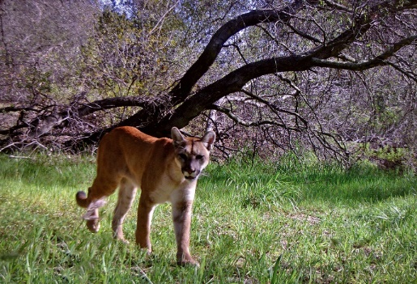
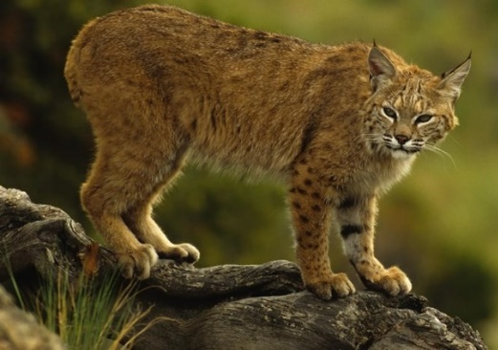

Mountain Lion (Puma concolor)
Carnivore – Secondary Consumer
Predators | Prey
Humans | Jack Rabbit, and rodents
Black Bear | Deer
 | Pigs
 | Birds, and eggs
 | Carrion
 | Condors
 | Pets

Bobcat (Canine latrans)
Carnivore – Secondary Consumer
Predators | Prey
Mountain Lion | Jack Rabbit, and rodents
Black Bear | Deer
 | Pets
 | Birds, and eggs
 | Carrion
 | Lizards
 | Condors

